Nucleosynthesis

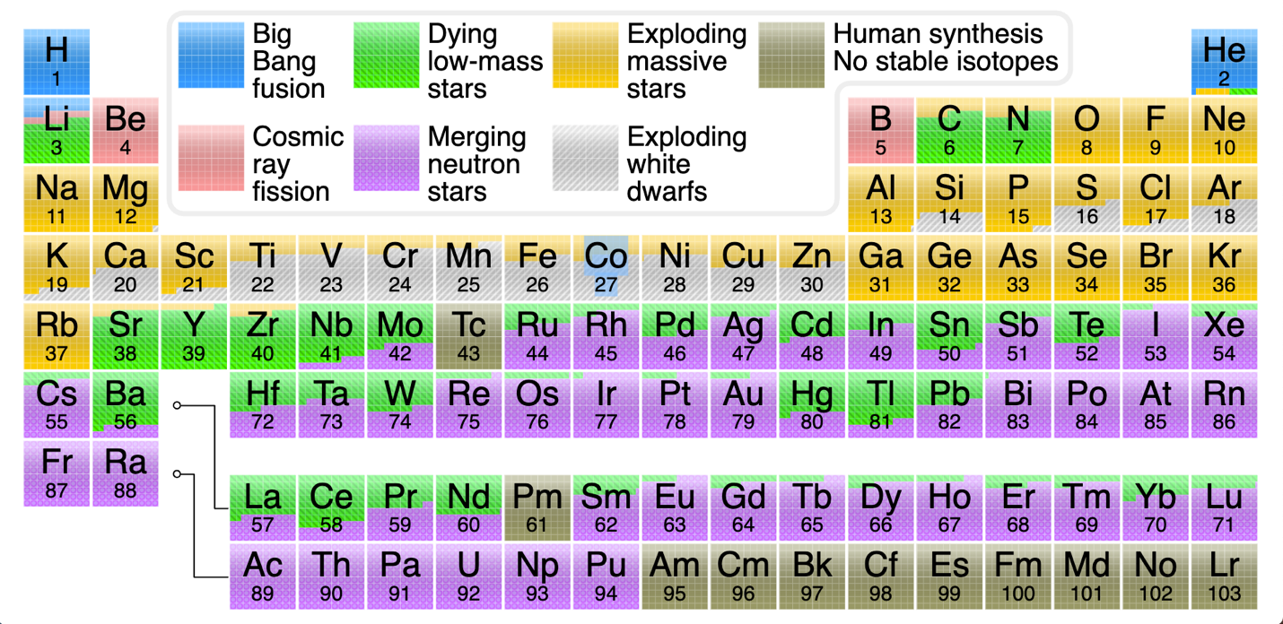

Nucleosynthesis of heavy nuclei in dying low-mass stars
Dying low-mass stars, like the Sun, primarily create heavy elements through the
slow neutron-capture process, known as the s-process. Unlike massive stars that produce elements up to iron through fusion and heavier elements in supernova explosions, low-mass stars do not reach the core temperatures necessary for advanced fusion. Instead, their contribution happens during the asymptotic giant branch (AGB) phase, as they shed their outer layers into space.

The s-process in AGB stars
The slow neutron-capture process is the main mechanism for creating heavy elements in low-mass stars.
- AGB phase: As a low-mass star runs out of hydrogen and helium fuel, its core contracts and heats up, causing its outer layers to expand dramatically. The star enters the AGB phase, a period of instability and intense mass loss.
- Neutron source: During thermal pulses in the AGB star's helium-burning shell, neutrons are released.
- Slow neutron capture: These neutrons are captured by existing "seed" nuclei, like iron, which were present from previous generations of stars. In the s-process, neutron captures happen slowly, giving the new isotope time to undergo beta decay—where a neutron becomes a proton—before another neutron is captured.
- Element production: This slow build-up of neutrons allows the creation of stable isotopes of elements heavier than iron, including barium, strontium, and lead.
Release of heavy elements
As the low-mass star's life ends, it sheds its outer layers in powerful stellar winds, creating a planetary nebula.
- This process enriches the interstellar medium with the s-process elements, as well as with carbon, nitrogen, and oxygen that were produced through earlier fusion.
- While an individual low-mass star adds a relatively small amount of heavy elements, their sheer abundance over billions of years means their collective contribution is significant for the overall chemical evolution of the galaxy.
The final stage: White dwarfs and Type Ia supernovae
After a low-mass star sheds its outer layers, it leaves behind a dense stellar remnant known as a white dwarf.
- In some binary star systems, a white dwarf can pull matter from a companion star. If the white dwarf's mass increases past a certain limit (the Chandrasekhar limit), it will undergo a runaway thermonuclear explosion.
- This explosion is a Type Ia supernova. It creates and disperses a large amount of elements up to the iron peak, including nickel and zinc, into the surrounding space. While these supernovae do not produce the very heaviest elements, they are a major source of iron for the cosmos.

How does neutron capture make atoms with atomic numbers greater than 26 (iron)?

When an atomic nucleus captures one or more neutrons, it is the process of beta decay that increases the atomic number, creating a new, heavier element. Neutron capture alone increases an atom's mass but does not change its atomic number, as neutrons are electrically neutral.
This process can occur in two primary astrophysical environments, leading to the formation of different heavy elements: the slow neutron-capture process (s-process) in stars and the rapid neutron-capture process (r-process) in more explosive events.
The process of neutron capture and beta decay
- Neutron capture: An existing atomic nucleus, often an isotope of iron, absorbs a free neutron. This increases the mass number of the atom by one but does not change its number of protons, so it remains the same element but becomes a heavier, often unstable, isotope.
- Beta decay: The newly formed, neutron-rich isotope is often unstable. To reach a more stable state, one of its neutrons transforms into a proton, an electron, and an antineutrino. The electron is immediately ejected from the nucleus as a "beta particle".
- Resulting element: Because the atom has gained a proton, its atomic number increases by one, and it becomes an atom of a new, heavier element.
This cycle of neutron capture followed by beta decay is the fundamental mechanism for building up elements heavier than iron.

Slow neutron capture (s-process)
In the s-process, neutron captures occur slowly, with enough time between captures for beta decay to happen. This allows the newly formed element to "climb" the periodic table one atomic number at a time.
- Astrophysical location: This process happens in stars of low to intermediate mass during their asymptotic giant branch (AGB) phase, where neutrons are produced at a low flux.
- Elements produced: The s-process forms about half of the elements heavier than iron, including stable isotopes of strontium, barium, and lead.

Rapid neutron capture (r-process)
In the r-process, atomic nuclei are bombarded with a dense flux of neutrons in an extremely short time. Multiple neutron captures occur in rapid succession before any beta decay can happen.
- Astrophysical location: This process requires environments with an extremely high density of free neutrons, such as during the merger of two neutron stars or possibly certain types of supernovae.
- Elements produced: This rapid build-up creates highly unstable, neutron-rich nuclei. Once the neutron flux subsides, these nuclei undergo a cascade of beta decays, forming the most massive elements, such as gold, platinum, uranium, and plutonium.

What is the composition, element-wise, of a neutron star?
- A neutron star's composition is not element-based in the traditional sense, but is instead structured in layers based on particle type and density
- The extreme gravity crushes atoms out of existence, forcing electrons and protons to combine into neutrons. Only in the outermost layer do recognizable elements exist.
Outer layer: Atmosphere and crust
The surface is the only part of a neutron star with a familiar atomic structure, though it is still incredibly dense.
- Atmosphere: A very thin atmosphere, only a few centimeters thick, sits on the star's surface. It is primarily composed of light elements like hydrogen and helium, which are remnants of the original star.
- Outer crust: Beneath the atmosphere, the pressure compacts atomic nuclei into an extremely rigid, solid lattice. At the very top, this crust is likely composed of iron nuclei, with a sea of relativistic electrons moving between them. Deeper in this layer, the pressure forces the nuclei to become more and more neutron-rich.
- Inner crust: As density and pressure increase, the nuclei become so neutron-rich that they begin to "drip" neutrons into a surrounding superfluid. This zone is described as "nuclear pasta," where the matter forms complex shapes like rods (spaghetti) and sheets (lasagna) as the nuclei are crushed.
Inner layers: Outer core and inner core
With increasing pressure, the nuclear pasta structures eventually dissolve entirely, and the composition becomes simpler.
- Outer core: This region is a liquid of neutron-degenerate matter, consisting mostly of neutrons along with a smaller proportion of protons and electrons. The charged particles create the star's powerful magnetic field as they move.
- Inner core: The composition of the deepest, most dense region is still highly speculative. Possible theoretical states of matter include:
  - Neutron fluid: A superfluid of neutrons, protons, and electrons, in a density too high for the creation of exotic particles.
  - Quark-gluon plasma: A "soup" of free-moving quarks and gluons, formed when the pressure is so immense it breaks down the neutrons themselves.
  - Exotic matter: Other exotic states, such as strange matter (containing strange quarks) or matter with mesons and pions, are also possible.

How does the collision of neutron stars create heavy elements?

The collision of neutron stars creates heavy elements
through the rapid neutron-capture process, or r-process. A merger unleashes an immense, high-speed outflow of matter, subjecting atomic nuclei to an intense bombardment of free neutrons. This environment allows for the rapid creation of elements heavier than iron, including gold, platinum, and uranium.

The rapid neutron-capture (r-process)
The r-process is a form of nucleosynthesis that operates on a much faster timescale than the s-process, which occurs in the peaceful environment of dying low-mass stars.
- Mass ejection: As two neutron stars spiral into each other, tidal forces rip them apart, flinging a considerable amount of neutron-rich material—up to several percent of a solar mass—into space.
- Neutron bombardment: The ejected matter forms a vast, expanding shell moving at a significant fraction of the speed of light. This material has an extremely high density of free neutrons.
- Rapid capture: Existing nuclei, left over from previous stellar generations, are subjected to a flood of neutrons. They absorb multiple neutrons in quick succession, far faster than the nuclei have time to undergo beta decay.
- Beta decay cascade: These newly formed, extremely neutron-rich nuclei are highly unstable. Once the neutron flux subsides, they stabilize by undergoing a rapid chain of beta decays, where each captured neutron becomes a proton.
- New, stable elements: The cascade of beta decays increases the atomic number of the nuclei, quickly creating stable isotopes of very heavy elements.

Evidence for neutron star mergers as cosmic forges
Observational and theoretical evidence indicates that neutron star mergers are a primary source of the universe's heaviest elements.
- GW170817: The landmark detection of gravitational waves from the merger of two neutron stars (GW170817) in 2017 provided the first direct confirmation of this process. The detection was followed by the observation of a "kilonova," a brilliant afterglow caused by the radioactive decay of the newly created r-process elements in the ejected material.
- Observational confirmation: Analysis of the kilonova's spectrum allowed astronomers to identify the presence of heavy elements like strontium. Later observations of a different kilonova with the James Webb Space Telescope detected tellurium, confirming the production of an even wider range of heavy elements.
- High elemental yields: A single kilonova event can generate an enormous amount of heavy elements. Observations of one neutron star merger indicated it produced about 1,000 times the Earth's mass in very heavy elements.
- Galactic contribution: Models suggest that the amount of heavy r-process material in the Milky Way is consistent with the estimated frequency of neutron star mergers. The findings from GW170817 imply that such mergers are a dominant mode of r-process production in our galaxy.

Explain nucleosynthesis in exploding massive stars.
Nucleosynthesis in exploding massive stars, known as Type II supernovae, is
a two-part process that creates and releases a wide range of elements into the interstellar medium. First, a massive star builds up a layered, onion-like structure of elements during its lifetime. The final, explosive stage creates and distributes elements through shock-induced burning and neutron-capture processes.
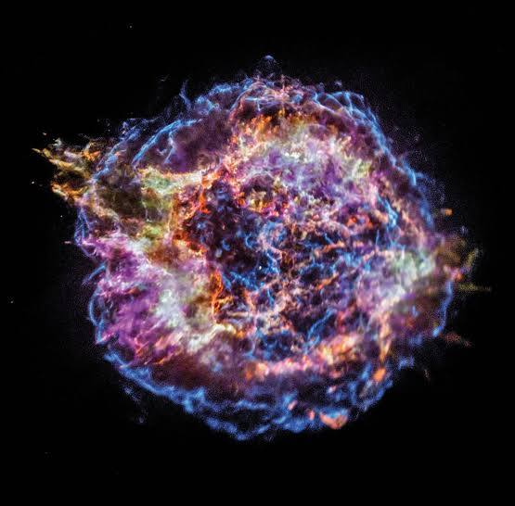
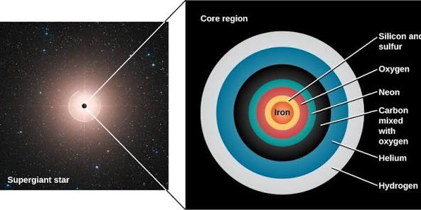
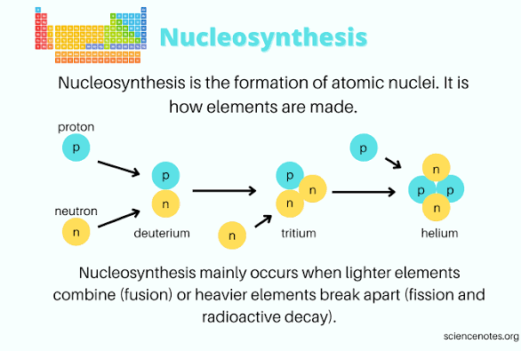

Pre-supernova nucleosynthesis (stellar burning)
Over their millions of years of life, massive stars (more than about 8 solar masses) fuse progressively heavier elements in their cores, producing nested shells of different elements. This "stellar burning" ends when the core is converted into iron.
- Hydrogen burning: In the star's core, hydrogen is fused into helium.
- Helium burning: Once the hydrogen fuel is exhausted, the core contracts and heats, fusing helium into carbon and oxygen via the triple-alpha process.
- Advanced burning stages: In successive phases, the star fuses carbon, oxygen, and then silicon to create heavier elements. This burning occurs in nested shells surrounding an inert iron core.
- The iron core: Iron is the end point of fusion because its nucleus is the most stable of all elements. Further fusion would absorb energy rather than release it, meaning the star can no longer support itself against gravity.
Explosive nucleosynthesis (during the supernova)
The collapse of the iron core and the subsequent supernova explosion provide the high-energy conditions needed to create elements heavier than iron.
- Core-collapse: When the iron core exceeds a critical mass (the Chandrasekhar limit), it can no longer withstand the force of gravity and collapses within a second.
- Shockwave formation: The immense pressure of the collapse forces protons and electrons to merge, forming neutrons and releasing a flood of neutrinos. When the inner core reaches nuclear density, the collapse abruptly halts and rebounds, creating a powerful shockwave that travels outward.
- Shock-induced fusion: As the shockwave blasts through the star's outer layers, it briefly but intensely raises temperatures, triggering explosive nuclear burning in the pre-existing shells of elements. This creates new elements and isotopes, including a significant amount of radioactive nickel-56, which later decays to form stable iron-56.
- The rapid neutron-capture process (r-process): The supernova core contains a high density of free neutrons. While the precise details are still under study, it is believed that these conditions create a "rapid neutron-capture process" (r-process).
  - In the r-process, atomic nuclei are barraged by a high flux of neutrons and absorb them faster than they can undergo beta decay.
  - This produces extremely neutron-rich, unstable nuclei. Once the neutron flux subsides, these nuclei undergo a cascade of beta decays, transforming neutrons into protons and creating stable heavy elements.
  - The r-process is responsible for creating roughly half of all heavy elements, including very heavy ones like gold, platinum, and uranium.
- Release into space: The resulting explosion ejects the freshly synthesized elements, along with the products of earlier stellar burning, into the interstellar medium. This enriched gas provides the raw materials for future generations of stars and planets.

