Baton Rouge North Wastewater Treatment Plant

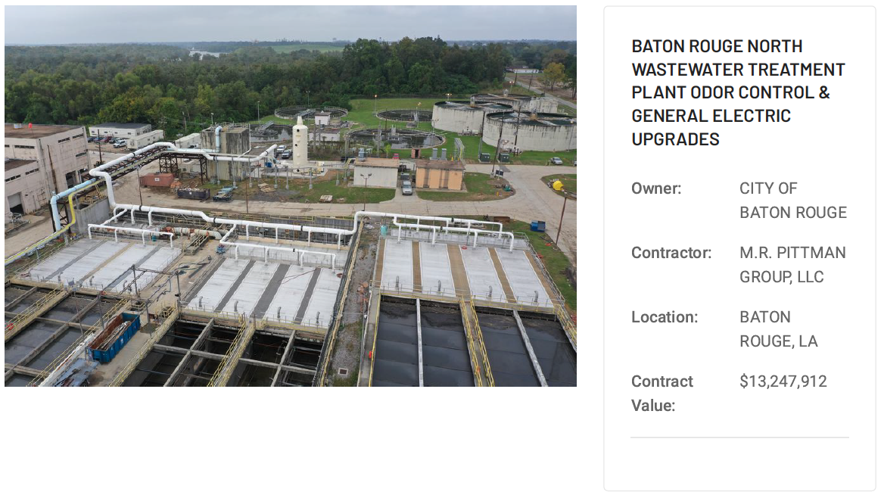
Where is the Baton Rouge North Wastewater Treatment Plant located?

The Baton Rouge North Wastewater Treatment Plant
is located at 55 Mills Avenue in East Baton Rouge Parish. This facility is situated behind Southern University.

