Iron oxidation number in hemoglobin
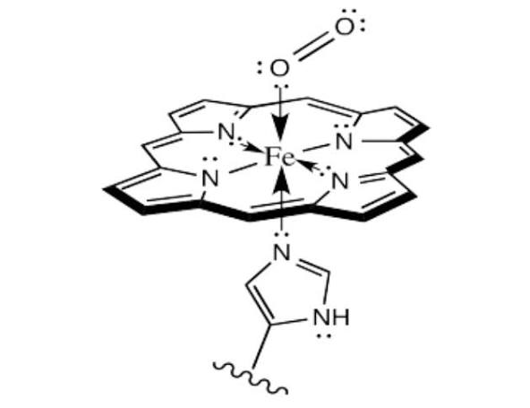

Deoxyhemoglobin (without oxygen)
In deoxyhemoglobin, the iron is in the +2 oxidation state (Fe²⁺). This form is also known as ferrous iron. In this state, the iron atom is slightly too large to fit neatly into the porphyrin ring of the heme group and is displaced slightly above the plane.
Oxyhemoglobin (with oxygen)
When oxygen binds to the heme group, the oxidation number of iron is formally +3 (Fe³⁺).
- This change is best understood as a charge transfer complex, where an electron is transferred from the iron(II) to the oxygen molecule, which becomes a superoxide anion (
- The diamagnetic properties of oxyhemoglobin provide strong evidence for this charge transfer. This is because the unpaired electron on the Fe³⁺ ion and the unpaired electron on the superoxide cancel each other out through a process called antiferromagnetic coupling.
- As a result of losing an electron, the iron atom becomes smaller and moves into the plane of the porphyrin ring. This conformational change is what triggers the cooperative binding of oxygen to the other subunits of the hemoglobin molecule.

In summary:
- Deoxyhemoglobin: Iron oxidation number is +2.
- Oxyhemoglobin: Iron oxidation number is formally +3, with the oxygen existing as a superoxide ion

